**EXPERIMENT-3**

**Aim-** To create a Docker network and attach it with containers for inter connectivity.

**Procedure:**

To create your own network use the following command: **docker network create <networkname>**. To see all the existed network use the **docker network ls** command.

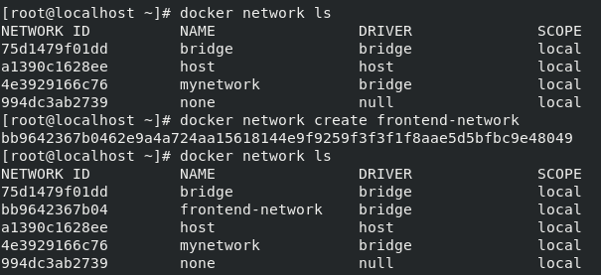

To launch a container inside a network use option **--net=<network-name>** while launching a container.  
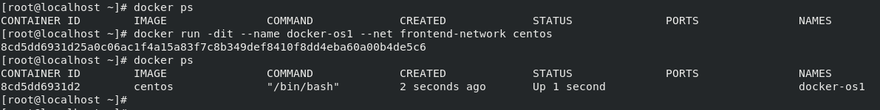

To see the network details of the container and check if it is inside the specified network use the **docker inspect** command. This command gives all the details about the container.

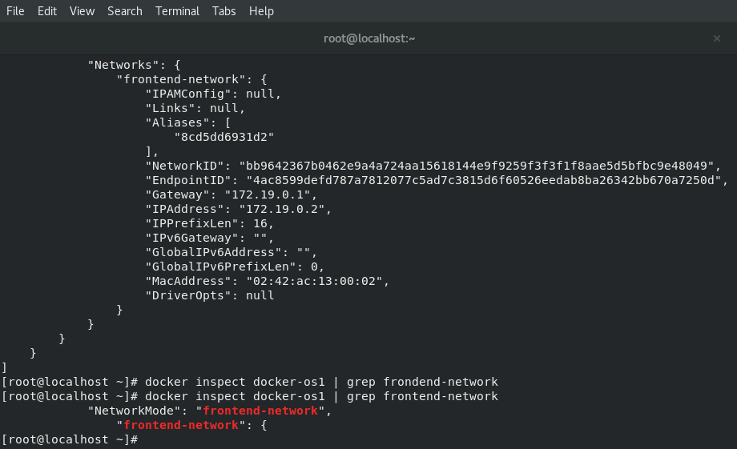

Now we will launch another container within same network as done in step-1. Two containers inside the same network can connect to each other with just container name provided. Use **ping** command from one container to ping another container from same network.  
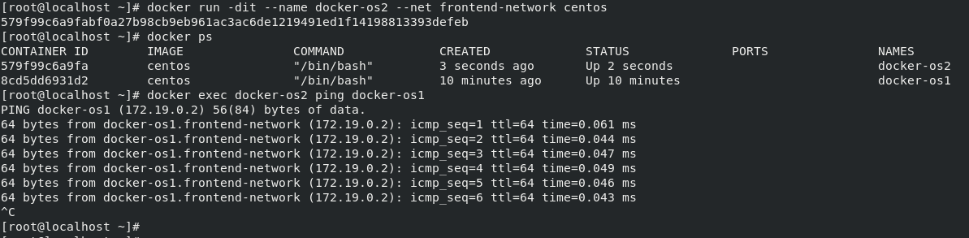

A container can be connected to more than one network at a time. For this, create another network and attach it to any one container we just created. Use command  
**docker inspect** to check it.

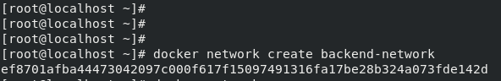  
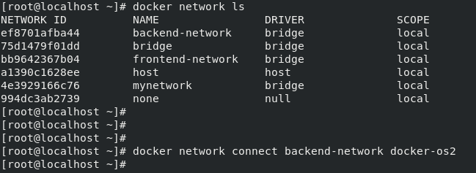  
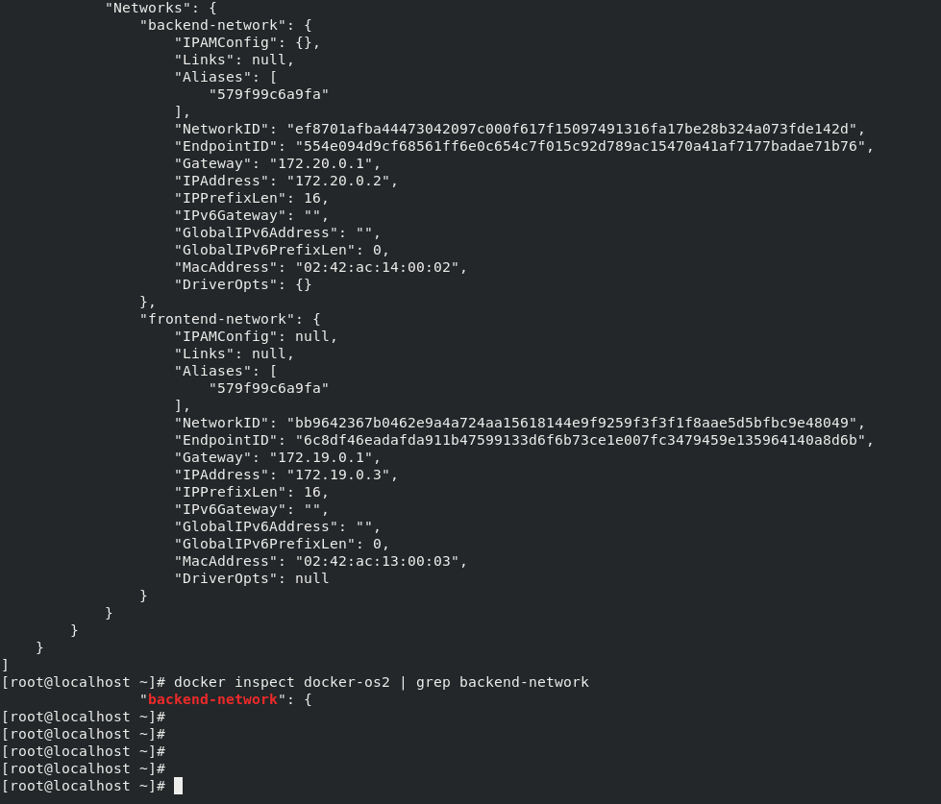

While connecting a network with a container, use option **--alias** to give alias to the container within the network. Now we can connect with this container using its alias name. Using the **ping** command to verify.

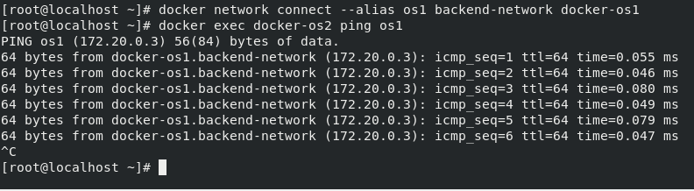

**Submitted by:**

ArjunRekhi

500068019  
R171218028